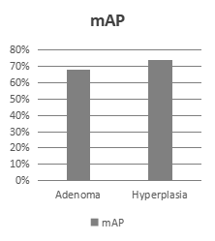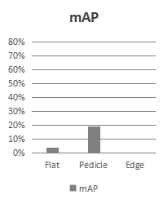

Expected

category

Flat Pedicle Edge

267 97 72

206 200 206

353 224 199

350 336 419

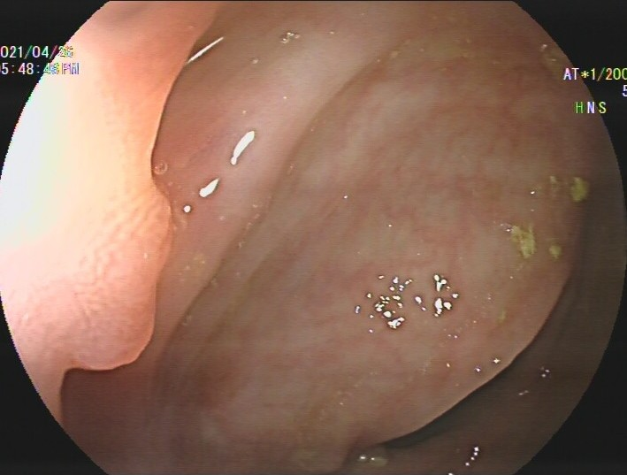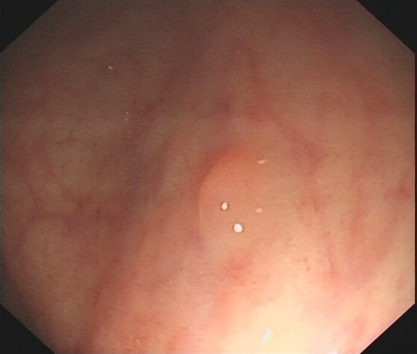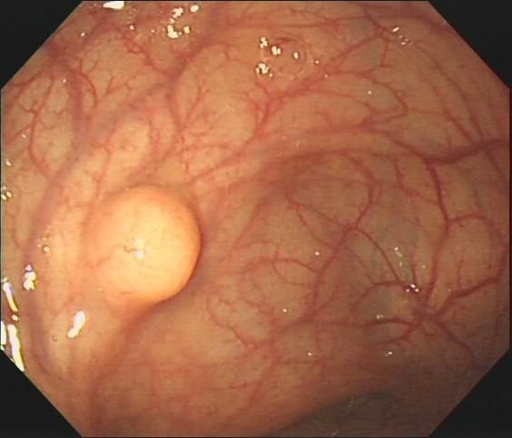

Class

Xmin

Ymin

Xmax

Ymax



**Box**

Annotated

More **time**

Image

Need **clinician**

**clinician**

**clinician**



Need **coordinate**

**(A)Shortcomings of existing methods :**

|  |  |  |  |  |
| --- | --- | --- | --- | --- |
| Images | | 图片2 | **图片3** | **图片1** |
| Prediction information | category | - | - | √ |
| confidence | - | √ | - |
| location | √ | √ | √ |





Hard Annotation Imperfect prediction Inappropriate pathology driven

**Advance 3**

**Advance 2**

**Advance 1**

**(B)Task of our work :**

|  |  |  |  |  |
| --- | --- | --- | --- | --- |
| Images | | **Flat:77%**  **Pedicle:89%**  **Edge:91%** |  | **Evaluate** |
| Prediction information | category | **√** | **√** | √ |
| confidence | **√** | √ | **√** |
| location | √ | √ | √ |

**Results**

**Supervised**

**Label**



Annotated

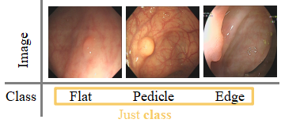

Less **time**



**Edge:91%**



**Padicle:89%%**

**Predict**

Just **class**

MDNet



**Flat:77%**

**Train**

**Image**

**Challenge 3**

**Challenge 2**

**Challenge 1**

**(C)Challenges of our task :**

|  |  |  |  |
| --- | --- | --- | --- |
| Images | 86648329A6024F4798C8046C1422E935_13174481 | 4E02AF94176C42728B1E1526F9BE6C65_GXNJ3194581 | 4E02AF94176C42728B1E1526F9BE6C65_GXNJ3194580  **?** |
| Flat |  | **?** | √ |
| Pedicle | **?** | √ |  |
| Edge | √ |  |  |

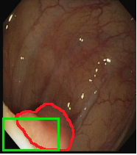

Ground truth

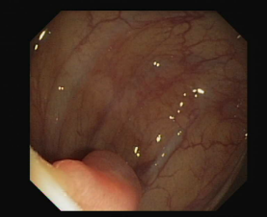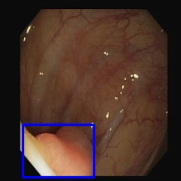

Image



Missed polyp

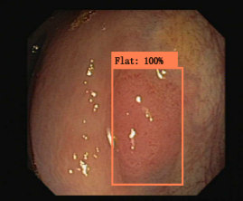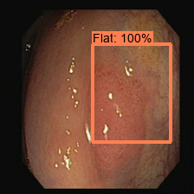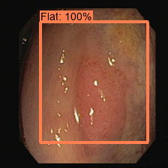

√

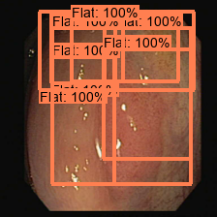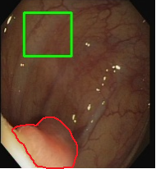

Wrong

location

**×**

Selective search

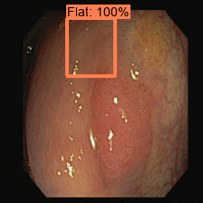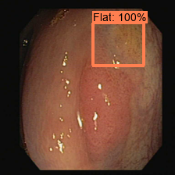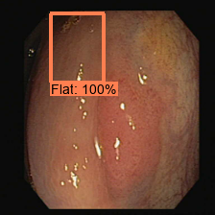

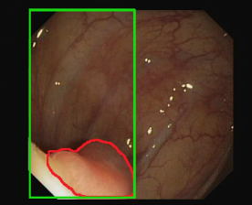

Unwanted

background noise

Inaccurate Proposals Indistinguishable shape Unexpected false positives

|  |  |  |  |  |
| --- | --- | --- | --- | --- |
| Images | |  |  |  |
| Prediction information | category | **×** | **×** | √ |
| confidence | **×** | √ | **×** |
| location | √ | √ | √ |

|  |  |  |  |  |
| --- | --- | --- | --- | --- |
| Images | | **Flat:77%**  **Pedicle:89%**  **Edge:91%** |  |  |
| Prediction information | category | √ | √ | √ |
| confidence | √ | √ | √ |
| location | √ | √ | √ |